Source ID - 931181302

Source Title - Finance: Theory and Practice

Current Issue URL - <https://financetp.fa.ru/jour/issue/current>

Russian and English TOC should be captured.

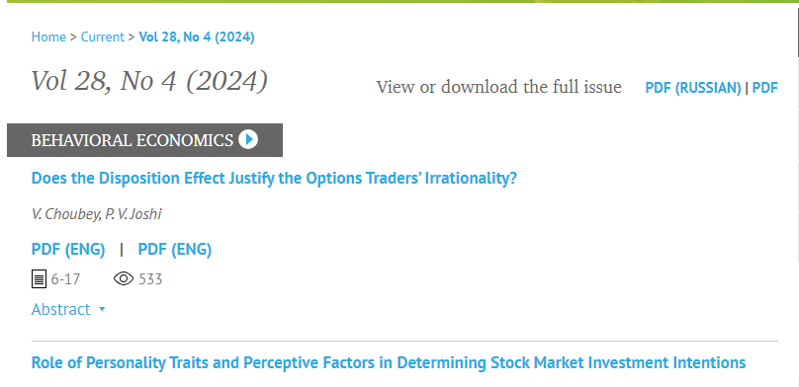

Page range

Click to capture meta data

Volume

Issue

Year

PDF

DOI

Article title